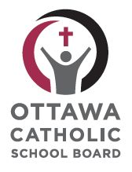

St. Mark Catholic High School
Grade 11 English, University ENG3U
2014-2015
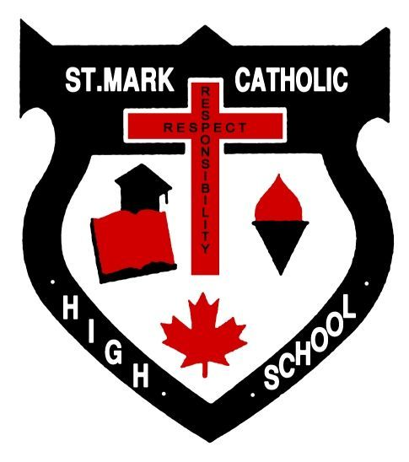

Teacher: Ms. Erin Bennett
Prerequisite Course: English, Grade 10, Academic (70 % or higher recommended)

Description and Overall Expectations: This course emphasizes the development of literacy, communication, and critical and creative thinking skills necessary for success in academic and daily life. Students will analyse challenging literary texts from various periods, countries, and cultures, as well as a range of informational and graphic texts, and create oral, written, and media texts in a variety of forms.

Oral Communication: listen in order to understand and respond appropriately in a variety of situations for a variety of purposes; use speaking skills and strategies appropriately to communicate with different audiences for a variety of purposes; reflect on and identify their strengths as listeners and speakers, areas for improvement, and the strategies they found most helpful in oral communication situations.

Reading and Literature Studies: read and demonstrate an understanding of a variety of literary, informational, and graphic texts, using a range of strategies to construct meaning; recognize a variety of text forms, text features, and stylistic elements and demonstrate understanding of how they help communicate meaning; use knowledge of words and cueing systems to read fluently; reflect on and identify their strengths as readers, areas for improvement, and the strategies they found most helpful before, during, and after reading.

Writing: generate, gather, and organize ideas and information to write for an intended purpose and audience; draft and revise their writing, using a variety of literary, informational, and graphic forms and stylistic elements appropriate for the purpose and audience; use editing, proofreading, and publishing skills and strategies, and knowledge of language conventions, to correct errors, refine expression, and present their work effectively; reflect on and identify their strengths as writers, areas for improvement, and the strategies they found most helpful at different stages in the writing process.

Media Studies: demonstrate an understanding of a variety of media texts; identify some media forms and explain how the conventions and techniques associated with them are used to create meaning; create a variety of media texts for different purposes and audiences, using appropriate forms, conventions, and techniques; reflect on and identify their strengths as media interpreters and creators, areas for improvement, and the strategies they found most helpful in understanding and creating media texts.

Course Resources:
Text | Number | Replacement Value | Returned
Night / The Great Gatsby |  | $25.00
Viewpoints |  | $35.00
Reference Points |  | $30.00
Macbeth / Othello |  | $25.00
Book Club Text |  | $20.00 -$35.00

Catholic Graduate Expectations: Our goal for all students is to experience an education based on our Catholic Graduate Expectations. http://www.iceont.ca
We work in community to develop graduates that are:
- Discerning Believers Formed in the Catholic Faith Community
- Effective Communicators
- Reflective and Creative Thinkers
- Self-Directed, Responsible, Life-Long Learners
- Collaborative Contributors
- Caring Family Members
- Responsible Citizens

Assessment, Evaluation and Reporting: The primary purpose of assessment and evaluation is to improve student learning. Students will understand what is expected of them, using learning goals, and success criteria, based on the overall expectations. Feedback (self, peer, teacher) supports learning, and plays a critical role in academic achievement and success.

The development of learning skills and work habits is a key indicator of future success. The following learning skills and work habits will be developed, assessed, and reported during this course:
- Responsibility fulfills responsibilities and commitments (e.g. accepts and acts on feedback)
- Organization manages time to complete tasks and achieve goals (e.g. meets goals, on time)
- Independent work uses class time appropriately to complete tasks (e.g. monitors own learning)
- Collaboration works with others, promotes critical thinking (e.g. provides feedback to peers)
- Initiative demonstrates curiosity and an interest in learning (e.g. sets high goals)
- Self-Regulation sets goals, monitors progress towards achieving goals (e.g. sets, reflects goals)

Group work supports collaboration, an important 21st century skill. This will be assessed only as a learning skill. Homework may also be assessed as a learning skill. Evaluation completed in class will be based only on individual student work. Regular attendance is important to support group work, various forms of feedback, and to allow students to demonstrate evidence of their learning. Students are responsible for providing evidence of their own learning (with references where required), in class, within given timelines. Next steps in response to academic integrity issues, such as lack of work completion, plagiarism, or other forms of cheating, range from providing alternate opportunities, to a deduction of marks.

The achievement chart identifies four levels, based on achievement of the overall expectations:
Level 1 achievement falls below the provincial standard (50-59%)
Level 2 achievement approaches the provincial standard (60-69%)
Level 3 achievement is at the provincial standard (70-79%)
Level 4 achievement surpasses the provincial standard (80-100%)
The report card grade will be based on evidence of student performance, including observations, conversations and student products. Consideration will be given to more recent evidence (skill development) and the most consistent level of achievement.

Mark Breakdown:
Term Work (70%) will include a variety of assessment tasks designed to demonstrate students’ development in their knowledge and understanding, thinking and inquiry, communication and application, of all overall expectations.
Summative evaluation (30%) takes place towards the end of the semester, is completed in class, and provides the final opportunity for students to demonstrate what they know, and the skills they have learned, based on the overall expectations. In ENG3U, the summative evaluation will consist of a rich summative assessment task (10%) and a final exam (20%).

Awarding of Course Credit: Students who demonstrate evidence of achievement of overall expectations, and earn a mark of 50% or greater, will earn one credit for the course with the following exception:
Students who do not complete their summative evaluation (exam and/or end of year summative task) will not earn their credit regardless of their mark.

Student and Parent/Guardian Acknowledgement
We have read the above course outline and are aware of the student responsibilities to attend class on a regular basis and to provide evidence of learning within the established timelines.

Student’s Name: ______________________________________________
Please print

Student’s Signature: ___________________________________________

Parent/Guardian Name: _________________________________________
Please print

Parent/Guardian Signature: ______________________________________

Course Outline and Unit Breakdown

1. Short Stories: Viewpoints (3 - 5 short stories will be studied) (10 %)
figurative language, rhetorical devices, tone diction, point of view, plot structure, theme
content quizzes and sight passage unit test
RST: short story literary essay (600 - 800 words)

2. Memoir Study: Elie Wiesel (Night) (25 %)
plot, characterization, historical reference, literary elements, style
guided reading questions and quizzes, vocabulary, unit test
RST: research paper (800-1000 words) / Optional Activity

3. Shakespearean Drama: ( Othello) (25 %)
Shakespeare’s language, dramatic structure, literary elements
comprehension questions, guided reading quizzes, unit test
RST: 800 - 1000 word literary essay with secondary sources

4. Media: Reference Points (10 %)
terms, format, language in media, identifying purpose, audience, and style; morality and
ethics
RST: editorial

5. Grammar and Essay Writing: Reference Points
Grammar: parts of speech, parts of a sentence, types of sentences, sentence problems, usage,
mechanics, and parallelism.
Essay Writing: essay structure, thesis and blueprint construction, use of direct quotations, MLA format,
research skills, note-taking, primary and secondary sources, evaluation of internet sources, creating a
research-based thesis, multi-paragraph research essays. Plagiarism, in its many forms, will not be
tolerated in this paper or in this course.

6. Novel Study: Book Club Format (10 %) - *** final RST
An array of grade level appropriate fiction.
Individual and group response
RST: group seminar

7. Final Exam (20 %)
Sight passage
Formal Persuasive Literary Academic essay
Exam date – 18 June 2015

