The word “mandala” is from Sanskrit and is loosely translated to mean circle. In different cultures a mandala is a “sacred circle” because it is a symbol of continuity, wholeness and spirituality. It represents the universe itself; it is a design that helps us relate to the infinite and the world that exists beyond our bodies and minds.
Mandalas appear in medicine wheels, dream catchers, teepees, sand mandalas, the yin-yang, Buddhist stupas, Muslim mosques, and even as stained glass windows in cathedrals like the North rose Window of Chartres Cathedral.
Tradition dictates the shapes, size and colours of mandalas.
The Tibetan word for mandala, dykil-‘khor , literally means “that which enters a center.” The center is the essence, the focus of a person’s meditation, and that which surrounds it has meaning. The outer parts of the mandala may contain squares or triangles and other symbols but the center should be concentric.
In religious traditions, the mandala has been used as a spiritual tool designed as a focal point for meditation and reflection. For Tibetans, the mandala is a calming tool used to think about the meaning of life.
Today, people often create mandalas to form a simple representation of who they are.

The basic structure of a mandala is as follows:

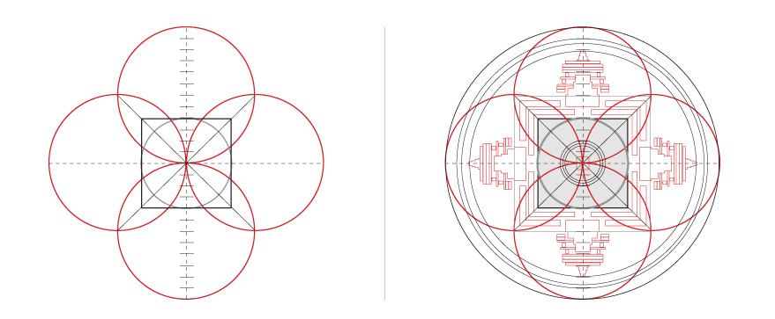
How to use a mandala
The design of a mandala is supposed to be visually appealing so that the mind is focused and can go to a higher consciousness or awareness. The busy mind is therefore given a break and the creative mind runs free.
Primarily, a mandala is a form of meditation to gain inner knowledge.
A person needs to be relaxed while creating the mandala. We need to learn to use our imaginations to see the inner self. Playing with shapes, colours, and symbols help one focus on the inner state.
The mandala needs to be balanced.
How to create a mandala
- Complete the “Symbol of my Life” graphic organizer or a similar tool to answer the questions:
  - What is significant in my life? For what am I grateful?
  - Who is important to me? For whom am I grateful?
  - What values are important to me?
  - Where is my favorite location? Why is it important? What does it represent? (eg. Grandma’s lap as a child meant love and security; under the stairs was my safe, alone place where I could solve problems)
  - What are the elements of my life? Friends, school. Home, family, sports, hobbies, interests, music, religion, dreams, inspirations, quotes, nature, culture

- Start with a rough draft. Lightly draw and choose a shape. Refer to:
  - choose a shape guidelines
  - mapping out mandalas
- Fill in the shape spontaneously, letting the drawing emerge in a creative way, like doodling. Or, you can plan out your mandala with images that come from deep reflection and relaxation.
  - The most important symbols for you should be in the middle with everything flowing around it.
  - Refer to symbols and colour meanings sheet
  - Know the difference between signs (one meaning) and symbols (interpret meaing)
- Darken the lines.
- Colour the shape. Be detailed.

