 | Sacrament | How often receive | minister | Who receives | Action & Words | Significance or MEANING | Symbols
Initiation | Baptism | not repeated | deacon, priest | Usually a baby  Anyone who wishes to become Catholic | Immersed in water  Priest says “I baptize you in the name of the Father, the Son and the Holy Spirit | Initiated into the Christian community  Spiritual passage from death to spiritual life in Christ  Frees one from original sin and guilt | 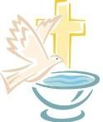  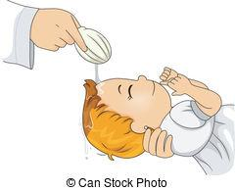
 | Eucharist | Repeated | deacon, priest | Received first time in grade 2  Received often by those who have been baptized Catholic and over age 7  Can be received once a day  Usually only on Sundays | Priest celebrates the Mass  Consecrates bread and wine by saying “this is my body/blood” which then become the body/blood of Christ  Invites people to meal by saying: “Behold the Lamb of God, behold Him who takes away the sins of the world.”  Congregation receives after saying “ Lord, I am not worthy that you should enter under my roof, but only say the word and my soul shall be healed.”  Eucharistic Minister then distributes the meal and says “the body (blood) of Christ” and we reply “Amen.” | Share body/blood of Christ  Growth in community  Come together as God’s people | 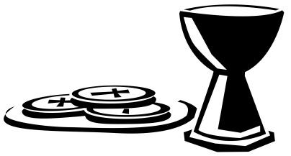
 | Confirmation | not repeated | Bishop | Teenagers usually but  Anyone who wishes to become Catholic | Bishop lays on hands  Anoints forehead with oil of Chrism  Says “be sealed with the holy Spirit” | Sealed with Holy Spirit  Witness to Christ; be priest, prophet, king  Completes act of initiation  To help change the world | 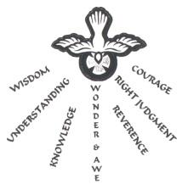  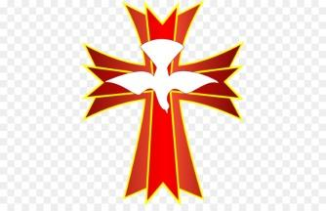
Healing & Reconciliation | Reconciliation | Repeated | priest | Start grade 2  Anyone can go every day | Open your heart and reflect on life  Examination of conscience  Act of contrition (sorry)  Confession to priest  Satisfaction – do penance  to atone for sins (pray,  do good deeds) | Ask God for forgiveness after committing a sin  To heal from our mistakes and repair our relationships  Forgiveness and healing  Restoration of relationships with God, self, and community | 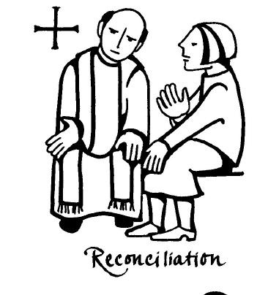
 | Anointing the Sick | Repeated | deacon, priest | Catholics who are seriously ill (cancer, Parkinsons, etc)  or  about to undergo major surgery | Pray over the person  Sprinkle with holy water  Read passage from  Scripture  Lay on hands  Anoint with oil on forehead and hands  Communion received | Compassion for sick  Still important part of community | 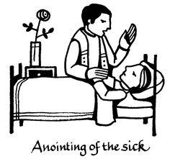  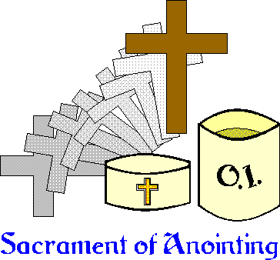
Service & Communion | Matrimony | not repeated  unless marriage annulled or death of spouse | priest | One woman and one man over the age of 18 who have received other sacraments | Interviews with priest/deacon  Present certificates of sacraments of initiation  Covenant – to serve each other  Vows of consent exchanged  Rings exchanged  Embrace  Sexual expression | Symbol of God’s love  Unity of partners (grow in love)  Procreation (life-giving)  Sign of union of Christ and the Church | 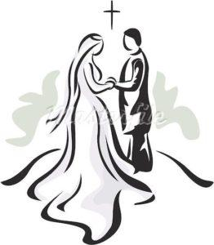  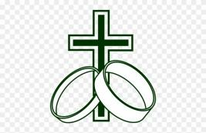
 | Holy Orders | Repeated  Once each level | Bishop  Pope | Baptized Catholic men over the age of 18 | Lay on hands  Sign of peace  Words of consecration  Bishop – oil, ring, mitre, shepherd’s staff  + Book of Gospel  Priest – vestments, oil, paten, chalice  Deacon – vestments + Book of Gospels | 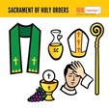  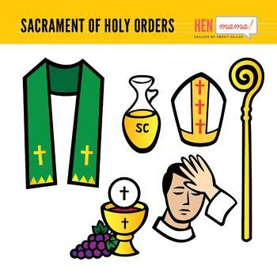  Christian ministry of service  Successors to apostles  Power to mediate grace through sacraments  Become leaders of the Christian community

